***VoIP***

*Task 1*

*Use Static addressing Scheme*

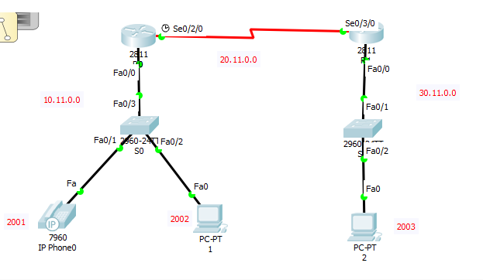

What you need to do

1. Show/verify end devices PC or IP phone has valid static IP addresses.
2. Show telephony services are configured using show running-configuration.
3. Verify PCs and IP phones has received their extension numbers.
4. Call from IP phone0 to PC2.

*Task 02*

*Use Dynamic IP approach (DHCP)*

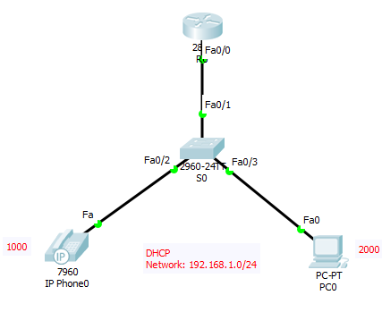

What you need to do

1. Show/verify DHCP is configured by showing PC address and using show running-configuration.
2. Show telephony services are configured using show running-configuration.
3. Verify PCs and IP phones received their extension numbers
4. Call from IP phone0 to PC0